**HOW TO SHARE A FOLDER**

Step By Step Guide

**WORKGROUP NAME CHANGE**

1. Go to my computer and then right click, go to properties, new window appear, under **Computer name, domain, and workgroup settings** section click on change settings button , then under computer name tab click change button, after that you can change the workgroup type **GOLIVE** and then click OK now restart the computer.

**If you want to share the folder**

1. Go to control panel, after that click **Network and Internet** there is a three option click **Network and Sharing Option** then on the left pane click **Change advanced sharing settings,** after that it shows three tabs
2. Under first 2 tabs change the option and turn on

* Turn on network discovery
* Turn on file and printer sharing

1. Under 3 tabs turn of password protected sharing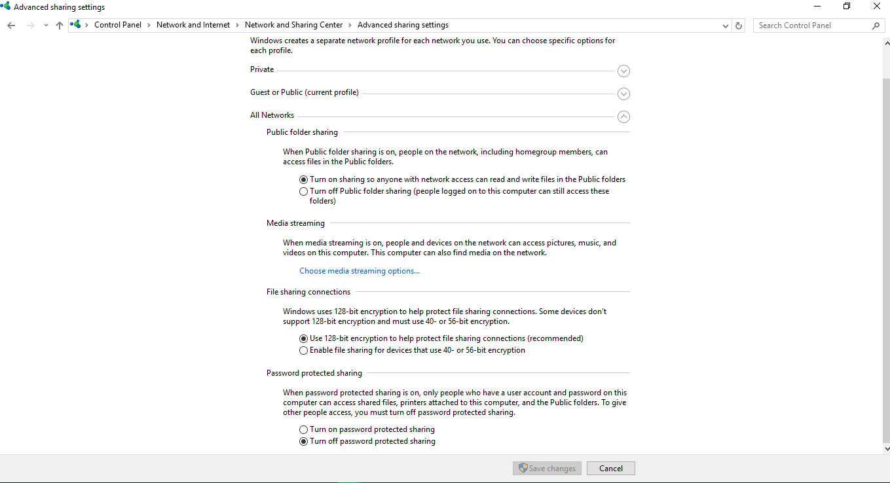
2. Now go to the **folder/file** which you want to share on network right click on that folder, there is an option **share with** expend that an click specific people new window appear
3. Choose people to share with, if you want to share with everyone then select **Everyone** and click **add** button click **OK** and then click **Done**

**If you want to access the folder**

1. **\\ComputerName**

**NOTE:**

Make sure when you share or access the folder both source or destination computer are on the same network